Name:____________________________________ Date:___________________________
Solving Linear Systems Algebraically
Example: Solve the following linear system: $\left\{\begin{aligned}y=6x-11 \\ -2x-3y=-7\end{aligned}\right.$
Step 1: Solve each equation for y.
$$-2x-3y=-7$$
$$-3y=2x-7$$
$$y=-\frac{2}{3}x+\frac{7}{3}$$
Step 2: Set the equations equal to each other.
$$6x-11=-\frac{2}{3}x+\frac{7}{3}$$
Step 3: Solve for x.
$$18x-33=-2x+7$$
$$20x-33=7$$
$$20x=40$$
$$x=2$$
Step 4: Plug the solution that you found for x in for x in one of the original equations.
$$y=6(2)-11$$
Step 5. Simplify to find y.
$$y=12-11$$
$$y=1$$
Step 6: Write the solution as an ordered pair.
SOLUTION:

TURN OVER ********************** TURN OVER ******************************TURN OVER
Solve the following systems algebraically. Check by graphing.
- $\left\{\begin{aligned}2x-3y=-1 \\ y=x-1\end{aligned}\right.$  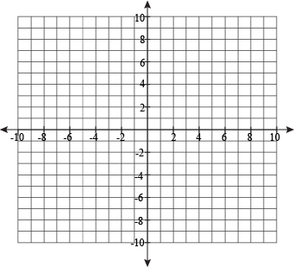 | - $\left\{\begin{aligned}y=-3x+5 \\ 5x-4y=-3\end{aligned}\right.$
- $\left\{\begin{aligned}y=5x-7 \\ -3x-2y=-12\end{aligned}\right.$ | - $\left\{\begin{aligned}-5x+y=-3 \\ 3x-8y=24\end{aligned}\right.$

