Lesson Summary

The slope of a line can be calculated using *any* two points on the same line because the slope triangles formed are similar, and corresponding sides will be equal in ratio.

Macintosh HD:Users:shassan:Desktop:discussion2.pdf

The *slope* of a non-vertical line in a coordinate plane that passes through two different points is the number given by the difference in $y$-coordinates of those points divided by the difference in the corresponding $x$-coordinates.   
For two points $P\left(p_{1},p_{2}\right)$ and $R\left(r_{1},r_{2}\right)$ on the line where $p_{1}≠r_{1}$, the slope of the line $m$ can be computed by the formula

$$m=\frac{p_{2}-r_{2}}{p_{1}-r_{1}} .$$

The slope of a vertical line is not defined.

Problem Set

1. Calculate the slope of the line using two different pairs of points.

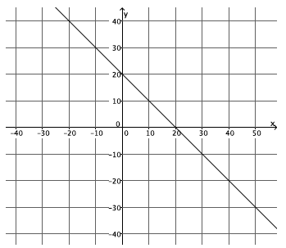

1. Calculate the slope of the line using two different pairs of points.

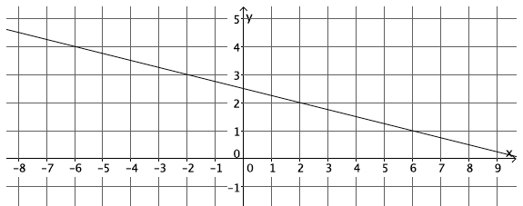

1. Calculate the slope of the line using two different pairs of points.

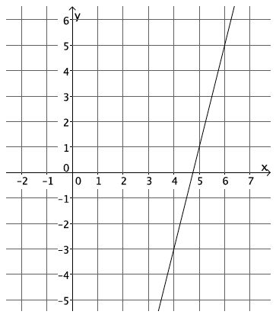

1. Calculate the slope of the line using two different pairs of points.

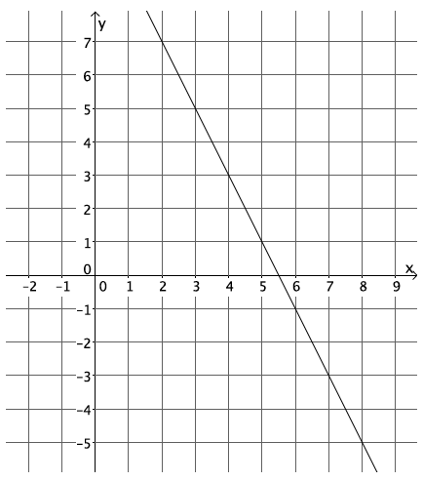

1. Calculate the slope of the line using two different pairs of points.

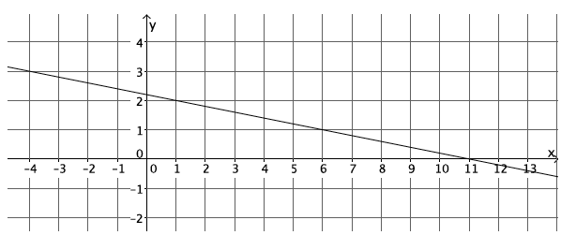

1. 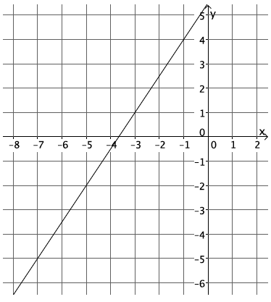Calculate the slope of the line using two different pairs of points.
   1. Select any two points on the line to compute the slope.
   2. Select two different points on the line to calculate the slope.
   3. What do you notice about your answers in parts (a) and (b)? Explain.
2. Calculate the slope of the line in the graph below.

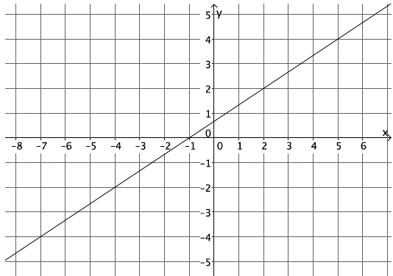

1. Your teacher tells you that a line goes through the points $\left(-6,\frac{1}{2}\right)$ and $(-4,3)$.
   1. Calculate the slope of this line.
   2. Do you think the slope will be the same if the order of the points is reversed? Verify by calculating the slope, and explain your result
2. 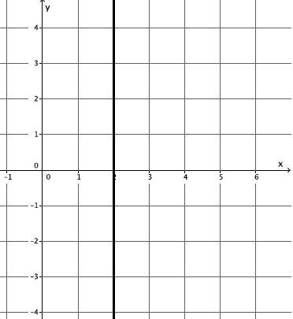Each of the lines in the lesson was non-vertical. Consider the slope of a vertical line, $x=2$. Select two points on the line to calculate slope. Based on your answer, why do you think the topic of slope focuses only on non-vertical lines?

Challenge:

1. A certain line has a slope of $\frac{1}{2}$. Name two points that may be on the line.