**Problem Set**

Lesson Summary

Dilations map lines to lines, rays to rays, and segments to segments. Dilations map angles to angles of the same degree.

1. Use a ruler to dilate the following figure from center $O$, with scale factor $r=\frac{1}{2}$.

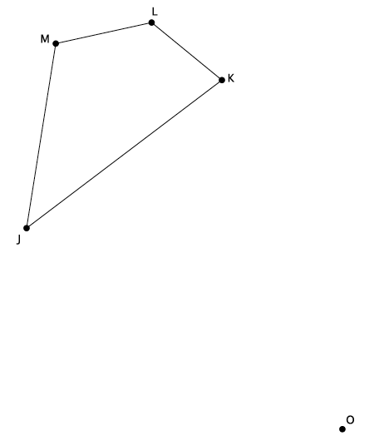

1. Use a compass to dilate the figure $ABCDE$ from center $O$, with scale factor .

Macintosh HD:Users:shassan:Dropbox:Module 3:Images:Properties of dilations:ps2s.pdf

* 1. Dilate the same figure, $ABCDE$, from a new center, $O'$, with scale factor $r=2$. Use double primes ($A''B''C''D''E''$) to distinguish this image from the original.
  2. What rigid motion, or sequence of rigid motions, would map $A''B''C''D''E''$*to $A'B'C'D'E'$*

1. Given center $O$ and triangle $ABC$, dilate the figure from center $O$ by a scale factor of $r=\frac{1}{4}$. Label the dilated triangle $A'B'C'$*.*

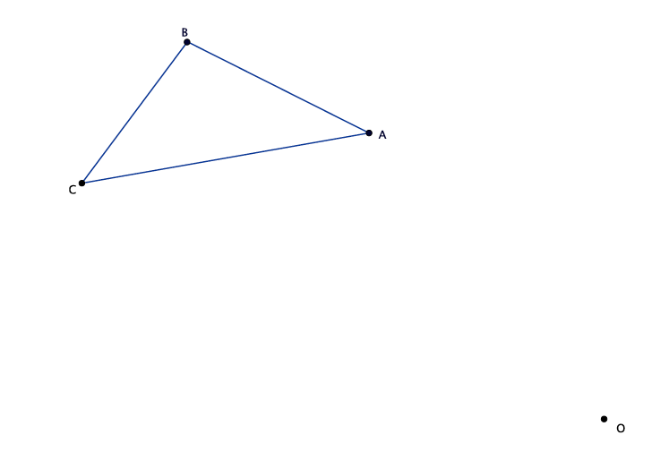

1. A line segment $AB$ undergoes a dilation. Based on today’s lesson, what will the image of the segment be?
2. Angle $∠GHI$ measures $78°$. After a dilation, what will the measure of $∠G'H'I'$ be? How do you know?