Problem Set
Lesson Summary
Definition: A dilation, a transformation of the plane with center $O$, with scale factor $r$ ($r>0$) is a rule that assigns to each point $P$ of the plane a point $Dilation(P)$ so that
- $Dilation(O)=O$, (i.e., a dilation does not move the center of dilation.)
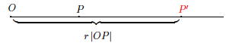
- If $P≠O$, then the point $Dilation(P)$, (to be denoted more simply by $P^{'}$) is the point on the ray $\vec{OP}$ so that $\left|{OP}^{'}\right|=r\left|OP\right|$.
In other words, a dilation is a rule that moves points in the plane a specific distance, determined by the scale factor $r$, from a center $O$. When the scale factor $r>1$, the dilation magnifies a figure. When the scale factor $0<r<1,$ the dilation shrinks a figure. When the scale factor $r=1$, there is no change in the size of the figure; that is, the figure and its image are congruent.

- Let there be a dilation from center $O$. Then $Dilation(P)=P^{'}$ and $Dilation(Q)=Q^{'}$. Examine the drawing below. What can you determine about the scale factor of the dilation?
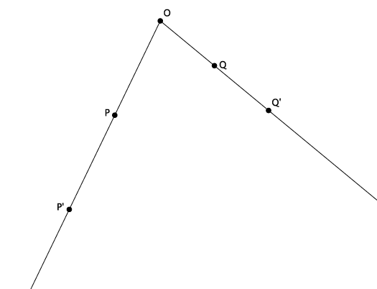

- Let there be a dilation from center $O$. Then $Dilation(P)=P^{'}$, and $Dilation(Q)=Q^{'}$. Examine the drawing below. What can you determine about the scale factor of the dilation?
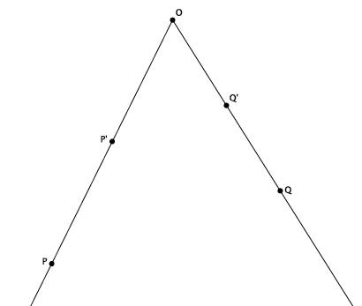

- Let there be a dilation from center $O$ with a scale factor $r=4$. Then $Dilation(P)=P^{'}$ and $Dilation(Q)=Q^{'}$. $\left|OP\right|=3.2$ cm, and $\left|OQ\right|=2.7$ cm, as shown. Use the drawing below to answer parts (a) and (b). Drawing not to scale.
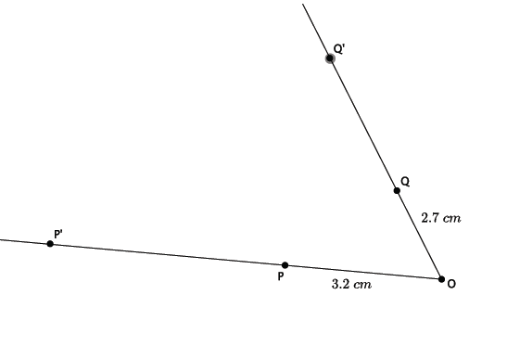
  - Use the definition of dilation to determine the length of ${OP}^{'}$.
  - Use the definition of dilation to determine the length of $OQ’.$
- Let there be a dilation from center $O$ with a scale factor $r$. Then $Dilation(A)=A^{'}$, $Dilation\left(B\right)=B^{'},$ and $Dilation(C)=C'$. $\left|OA\right|=3$, $\left|OB\right|=15$, $\left|OC\right|=6$, and $\left|{OB}^{'}\right|=5$, as shown. Use the drawing below to answer parts (a)–(c).
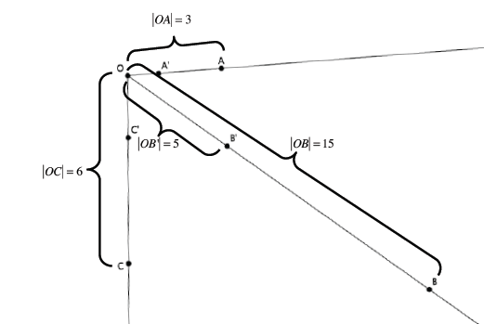

  - Using the definition of dilation with lengths $OB$ and ${OB}^{'}$, determine the scale factor of the dilation.
  - Use the definition of dilation to determine the length of ${OA}^{'}$.
  - Use the definition of dilation to determine the length of ${OC}^{'}$.

