Problem Set

- The world’s tallest living tree is a redwood in California. It’s about $370$ feet tall. In a local park, there is a very tall tree. You want to find out if the tree in the local park is anywhere near the height of the famous redwood.

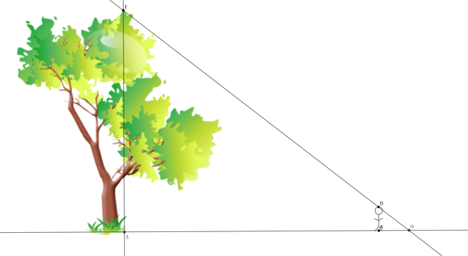

  - Describe the triangles in the diagram, and explain how you know they are similar or not.
  - Assume $△ESO\sim △DRO.$A friend stands in the shadow of the tree. He is exactly $5.5$ feet tall and casts a shadow of $12$ feet. Is there enough information to determine the height of the tree? If so, determine the height. If not, state what additional information is needed.
  - Your friend stands exactly $477$ feet from the base of the tree. Given this new information, determine about how many feet taller the world’s tallest tree is compared to the one in the local park.
  - Assume that your friend stands in the shadow of the world’s tallest redwood and the length of his shadow is just $8$ feet long. How long is the shadow cast by the tree?

- A reasonable skateboard ramp makes a $25˚$ angle with the ground. A two feet tall ramp requires about $4.3$ feet of wood along the base and about $4.7$ feet of wood from the ground to the top of the two-foot height to make the ramp.
  - Sketch a diagram to represent the situation.
  - Your friend is a daredevil and has decided to build a ramp that is $5$ feet tall. What length of wood will be needed to make the base of the ramp? Explain your answer using properties of similar triangles.
  - What length of wood is required to go from the ground to the top of the $5$-foot height to make the ramp? Explain your answer using properties of similar triangles.

