Name Date
- Write and solve each of the following linear equations.

  - Romeo has a certain amount of candy hearts. If he eats 15 of them, then he has $\frac{1}{4}$ of the original amount left. How many candy hearts did Romeo have initially?

  - Three consecutive integers have a sum of $126$. What are the three integers?

  - Heather is reading a book that has $186$ pages. She already read some of it last week. She plans to read $20$ pages tomorrow. By then, she will be $\frac{2}{3}$ of the way through the book. How many pages did Heather read last week?

  - Without solving, identify whether each of the following equations has a unique solution, no solution,
or infinitely many solutions.

    - $2x+3=3x+4-x$

    - $6\left(x-12\right)=3\left(x-4\right)+1(3x-60)$

    - $12x+9=8x+1+4x$

    - $2\left(x-3\right)=10x-6-8x$

    - $3x+10=8x-2$

  - Solve the following equation for a number $x$. Verify that your solution is correct.

$5x+2=-13$

  - Solve the following equation for a number $x$. Verify that your solution is correct.

$$5x-2+3x=4(x+6)$$

  - The Incredible Hulk paid $\$8.75$ for five pounds of protein powder. Assuming each pound of protein powder costs the same amount, complete the table of values representing the cost of protein powder in pounds.
Protein Powder in Pounds $(x)$ | $$1$$ | $$2$$ | $$3$$ | $$4$$ | $$5$$ | $$6$$ | $$7$$ | $$8$$
Cost in Dollars $(y)$ |  |  |  |  | $$\$8.75$$
  - Graph the data on the coordinate plane.
0 1 2 3 4 5 6 7 8 9 10 11
14
13
12
11
10
9
8
7
6
5
4
3
2
1
  - On the same day, Incredible Hulk’s friend, Spiderman, was charged $\$6$ for $2.5$ $lbs$. of protein powder. Explain in terms of the graph why this must be a mistake.

BONUS: What is the equation of the line that you drew in 3b?

A Progression Toward Mastery
Assessment  Task Item |  | STEP 1  Missing or incorrect answer and little evidence of reasoning or application of mathematics to solve the problem. | STEP 2  Missing or incorrect answer but evidence of some reasoning or application of mathematics to solve the problem. | STEP 3  A correct answer with some evidence of reasoning or application of mathematics to solve the problem, OR an incorrect answer with substantial evidence of solid reasoning or application of mathematics to solve the problem. | STEP 4  A correct answer supported by substantial evidence of solid reasoning or application of mathematics to solve the problem.
1 | a  8.EE.C.7b | Student makes no attempt to solve the problem or leaves the problem blank.  OR  Student may or may not have identified the variable. | Student does not set up an equation (i.e., guesses the answer).  OR  Student may or may not have identified the variable. | Student may or may not have set up the correct equation.  OR  Student may or may not have identified the variable.  OR  Student makes calculation errors. | Student identifies the variable as, “Let $x$ be the amount of money Ofelia had,” or something similar.  AND  Student sets up a correct equation, $x-12=\frac{1}{5}x$ or other equivalent version.  AND  Student solves for the variable correctly,  $x=15$.
 | b  8.EE.C.7b | Student makes no attempt to solve the problem or leaves the problem blank.  OR  Student may or may not have identified the variable. | Student does not set up an equation (i.e., guesses the answer).  OR  Student may or may not have identified the variable.  OR  Student makes calculation errors.  OR  Student only answers part of the question, stating, for example, that the first number is $77$, but does not give all three numbers. | Student attempts to set up an equation but may have set up an incorrect equation.  OR  Student may or may not have identified the variable.  OR  Student makes calculation errors.  OR  Student only answers part of the question, stating, for example, that the first number is $77$, but does not give all three numbers. | Student identifies the variable as, “Let $x$ be the first integer.”  AND  Student sets up a correct equation, $3x+3=234$ or other equivalent version.  AND  Student solves the equation correctly and identifies all three numbers correctly (i.e., $77$, $78$, and $79$).
 | c  8.EE.C.7b | Student makes no attempt to solve the problem or leaves the problem blank.  OR  Student may or may not have identified the variable. | Student does not set up an equation (i.e., guesses the answer).  OR  Student may or may not have identified the variable. | Student attempts to set up an equation but may have set up an incorrect equation.  OR  Student may or may not have identified the variable.  OR  Student makes calculation errors leading to an incorrect answer. | Student identifies the variable as, “Let $x$be the number of pages Gil read last week,” or something similar.  AND  Student sets up a correct equation, $x+20=184$ or other equivalent version.  AND  Student solves for the number of pages Gil read last week as $164$ pages.
2 | a  8.EE.C.7a | Student makes no attempt to determine the type of solution or leaves the problem blank.  OR  Student determines $0$ of the solution types correctly.  OR  Student may have attempted to determine the solutions by solving. | Student determines 1–2 of the solution types correctly.  OR  Student may have attempted to determine the solutions by solving. | Student determines  3–5 of the solution types correctly.  OR  Student may have attempted to determine the solutions by solving. | Student determines 5 of the solution types correctly. Equations 1 and 2 have unique solutions, equation 3 has no solution, equation 4 has infinitely many solutions, and equation 5 has no solution.  AND  Student determines the solutions by observation only.
 | b  8.EE.C.7b | Student makes no attempt to solve the problem or leaves the problem blank. | Student uses properties of equality incorrectly, (e.g., subtracts $1$ from just one side of the equation or divides by $8$ on just one side of the equation), leading to an incorrect solution. | Student correctly uses properties of rational numbers to solve the equation but makes a computational error leading to an incorrect solution. For example, student may have subtracted $1$ from each side of the equation, but $-15-1$ led to an incorrect answer. Student may or may not have verified the answer. | Student correctly uses properties of rational numbers to solve the equation (i.e., finds  $x=-2$). There is evidence that student verifies the solution.
 | c  8.EE.C.7b | Student makes no attempt to solve the problem or leaves the problem blank. | Student uses the distributive property incorrectly on both sides of the equation (e.g., $7\left(2x+5\right)=14x$ + 5 or $4x-x=4$), leading to an incorrect solution. | Student uses the distributive property correctly on one or both sides of the equation but makes a computational error leading to an incorrect solution.  Student may or may not have verified the answer. | Student uses the distributive property correctly on both sides of the equation leading to a correct solution (i.e.,  $x=-4$). There is evidence that student verifies the solution.
3 | a  8.EE.B.5 | Student makes no attempt to complete the table or uses completely random numbers in the blanks. | Student completes the table incorrectly but only because of a simple computational error in finding the cost of one pound of candy, leading to all other parts being incorrect. | Student completes 6–7 parts of the table correctly. A computational error leads to 1–2 parts being incorrect. | Student completes all 8 parts of the table correctly. (See the table below for the correct answers.)
Gummy Candy in Pounds ($x$) | $$1$$ | $$2$$ | $$3$$ | $$4$$ | $$5$$ | $$6$$ | $$7$$ | $$8$$ | $$9$$
Cost in Dollars ($y$) | $$1.50$$ | $$3.00$$ | $$4.50$$ | $$6.00$$ | $$7.50$$ | $$9.00$$ | $$10.50$$ | $$12.00$$ | $$13.50$$

 | b  8.EE.B.5 | Student makes no attempt to put the data on the graph, or points are graphed randomly. | Student plots data points on the graph but misplaces a few points.  OR  Student inverses the data (i.e., plots points according to $(y, x)$ instead of $(x, y)$). | Student plots 6–8 data points correctly according to the data in the table. | Student plots all 9 data points correctly according to the data in the table.
 | c  8.EE.B.5 | Student leaves the problem blank. | Student performs a computation to prove the mistake. Little or no reference to the graph is made in the argument. | Student makes a weak argument as to why $(1.5, 5)$could not be correct. Student may have connected the dots on the graph to show $(1.5, 5)$ could not be correct. | Student makes a convincing argument as to why the point $(1.5, 5)$ could not be correct. Student references the relationship being proportional and/or predicts that all points should fall into a line based on the existing pattern of points on the graph.

Name Date
- Write and solve each of the following linear equations.

  - Ofelia has a certain amount of money. If she spends $\$12$, then she has $\frac{1}{5}$ of the original amount left. How much money did Ofelia have originally?

  - Three consecutive integers have a sum of $234$. What are the three integers?

  - Gil is reading a book that has $276$ pages. He already read some of it last week. He plans to read
$20$ pages tomorrow. By then, he will be $\frac{2}{3}$ of the way through the book. How many pages did Gil read last week?
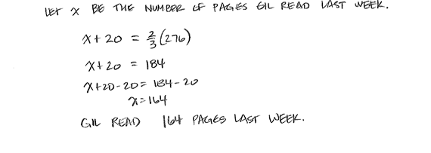

  - Without solving, identify whether each of the following equations has a unique solution, no solution,
or infinitely many solutions.
    - $3x+5=-2$

    - $6(x-11)=15-4x$

    - $12x+9=8x+1+4x$

    - $2\left(x-3\right)=10x-6-8x$

    - $5x+6=5x-4$

  - Solve the following equation for a number $x$. Verify that your solution is correct.

  - Solve the following equation for a number $x$. Verify that your solution is correct.
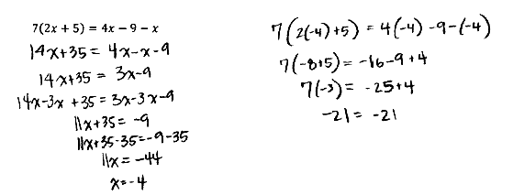

  - Parker paid $\$4.50$ for three pounds of gummy candy. Assuming each pound of gummy candy costs
the same amount, complete the table of values representing the cost of gummy candy in pounds.
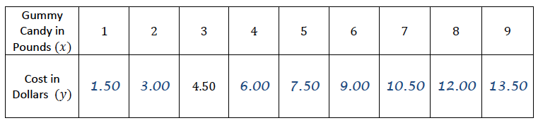
  - Graph the data on the coordinate plane.
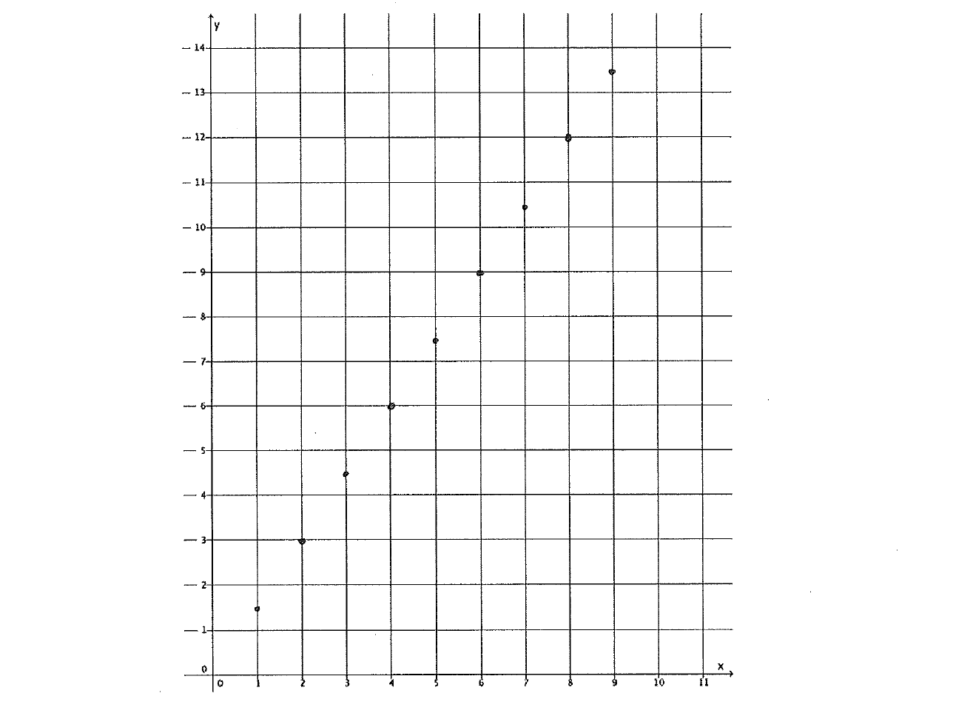

  - On the same day, Parker’s friend, Peggy, was charged $\$5$ for $1\frac{1}{2}$ $lb$. of gummy candy. Explain in terms of the graph why this must be a mistake.
