- Use the diagram below to answer the questions that follow.
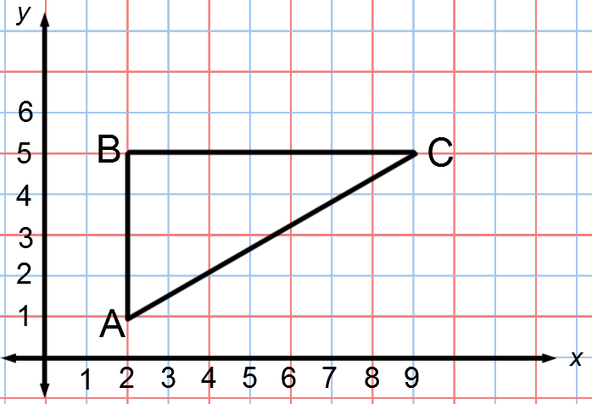
  - Dilate $△ABC$ from center $A$ and scale factor $r=\frac{3}{4}$. Label the image $△AB'C'$.

  - Find the coordinates of points $B'$ and $C'$.

  - Are $∠ACB$ and $∠AC'B'$ equal in measure? Explain.

  - What is the relationship between the segments $BC$ and $B'C'$? Explain in terms of similar triangles.

  - If the length of segment $AC$ is $8.1$ units, what is the length of segment $AC'$? Explain in terms of similar triangles.

- Use the diagram below to answer the questions that follow. The length of each segment are marked on the diagram. In addition, segment $OB$ is 14.5 cm.
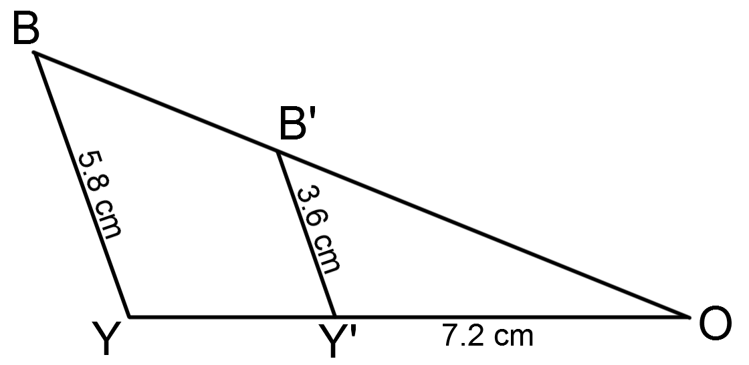
  - Suppose segment $BY$ is parallel to segment $B'Y'$. Is $△BOY$ similar to $△B'O'Y'$? Explain.

  - What is the length of segment $OB'$? Show your work.

  - What is the length of segment $OY$? Show your work.

- Given $△ABC \sim △A^{'}B^{'}C'$ and $△ABC \sim △A''B''C''$ in the diagram below, answer parts (a)–(c).
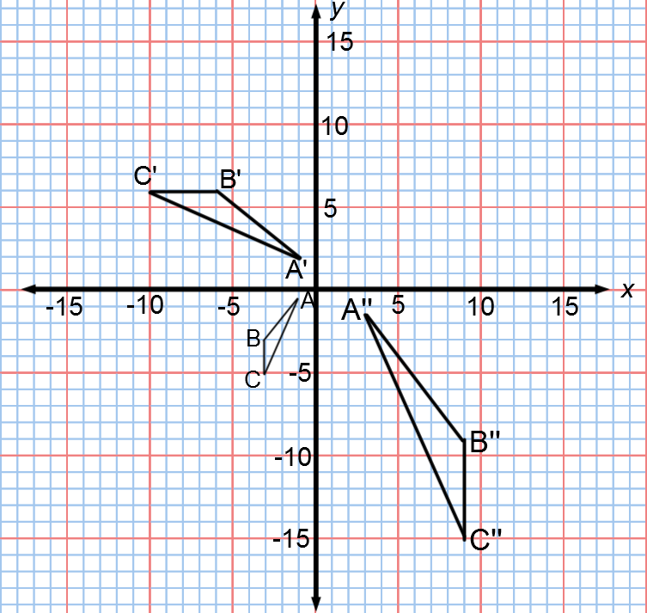
  - Describe the sequence that shows the similarity for $△ABC$ and $△A^{'}B^{'}C'$.

  - Describe the sequence that shows the similarity for $△ABC$ and $△A''B''C''$.

  - Is $△A^{'}B^{'}C'$ similar to $△A''B''C''$? How do you know?

