Name:__________________________________________ Date:_________________________
Describing Similarities Using Transformations
- Consider$∆ABC$, and $∆A'B'C'$ drawn on the coordinate plane below. Describe a dilation followed by a congruence (of one or more rigid motions) to show that $∆ABC∼∆A'B'C'$.
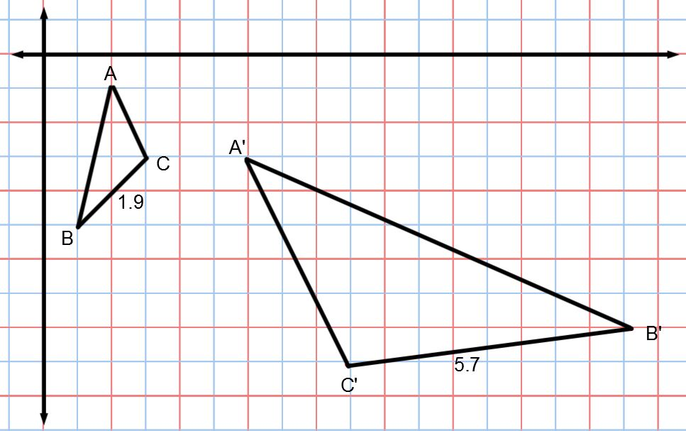

- Consider quadrilateral ABCD and quadrilateral A’B’C’D’. Describe a dilation followed by a congruence (of one or more rigid motions) to show that quadrilateral ABCD$∼$quadrilateral A’B’C’D’.

